Winnington Park Primary School and Nursery

Attendance and Punctuality Policy, including EBSN



Date: May 2023

Review Date: September 2025

Introduction and Aim

Winnington Park Primary School and Nursery recognises the importance of good attendance and the impact it has on children’s progress, attainment, enjoyment of learning and relationships within school. Good attendance helps a child to realise their potential and ensure they are motivated, confident and enjoy a diverse range of curricular opportunities and experiences. Our school policy and prospectus promote good attendance, which is recognised and rewarded as an achievement. The school monitors attendance and ensures quick and early intervention if a problem is identified. We recognise that whole school preventative and proactive approaches are key to promoting children wellbeing and attendance. A child must attend school every day that they are required to do so unless an exceptional circumstance applies.
Our policy is accessible to leaders, staff, pupils, and parents, and is published on our school website. It will be sent to Parents with any initial information when pupils join the school and reminded of it at the beginning of each school year and when it is updated. As the barriers to attendance evolve quickly, the policy should be reviewed and updated as necessary. The Attendance and Punctuality Policy is based on the premise of equal opportunities for all.

- Legislation

Regular and punctual attendance at school is a legal requirement. Regular attendance is essential to enable children to maximise their educational attainment, opportunities and further development.
- Section 7 of the Education Act 1996 states that “The parent of every child of compulsory school age shall cause him/her to receive efficient full-time education either by regular attendance at school or otherwise”.
- Section 444 (1) of the Education Act 1996 states that “if a child of compulsory school age who is a registered pupil at a school fails to attend regularly at the school his parent is guilty of an offence”.
- Section 576 Education Act 1996 - Meaning of “parent”

For the purposes of Education Law, the definition of a ‘parent’ and who is responsible for ensuring regular attendance to school is:
- all biological parents, whether they are married or not
- any person who, although not a biological parent, has parental responsibility for a child or young person - this could be an adoptive parent, a step-parent, guardian or other relative
- any person who, although not a biological parent and does not have parental responsibility, has care of a child or young person. This could be one parent, both parents and/or carer/s.

- Registers

Registers provide the daily record of attendance of all pupils. They are legal documents and the register may be required in a court of law, for example as evidence in prosecutions for non-attendance in school.

‘Education (Pupil Registration) (England) Regulations 2006’ (section 6)
Schools must take the attendance register at the start of the first session of each school day, morning (a.m.) and once during the second session, afternoon (p.m.).

On each occasion they must record whether every pupil is:
• Present
• Attending an approved educational activity
• Absent
• Unable to attend due to exceptional circumstances.

The school should follow up any absences to:
• Ascertain the reason
• Ensure the proper safeguarding action is taken
• Identify whether the absence is approved or not; and,
• Identify the correct code to use before entering it on to the school’s electronic register, or management information system as a priority and returned to the school office in a timely manner. This is used to download data to the School Census.
- Consider early identification, assessment, intervention and support processes that may need to be implemented.

The register should be marked using the codes as advised by the Department for Education (DfE) ‘Working together to improve School Attendance Guidance’ (for maintained schools, academies, independent schools and local authorities) https://assets.publishing.service.gov.uk/government/uploads/system/uploads/attachment_data/file/1073616/Working_together_to_improve_school_attendance.pdf (See appendix 3.)

- Procedure

Children are expected to attend school regularly, unless there is good reason for absence.
There are two types of absence:
- Authorised (where the school approves a pupil absence)
- Unauthorised (where school will not approve the absence)

The school has a duty to safeguard all its pupils. If a child is absent, the parents/carers should inform the school on the first day of absence and each following day of absence, stating the reason.
Contact the school office on 01606 74371 to speak to Mrs Robinson, Miss Moss or Mrs Wood. Parents/Carers should ring school in the first instance. Email admin@winningtonpark.cheshire.sch.uk if you are unable to get through – please keep trying to speak to a member of staff.
The name and contact details of the senior leader responsible for the strategic approach to attendance in school is the headteacher Mr Rob Cole.
The school office will make contact with home when a child is absent, and the parent/carer has not notified the school of the absence. If no contact can be achieved or the reason for absence is not accepted the absence will be unauthorised.

- What can parents/carers do to help and working in partnership with Parents/ Carers

Let the school know straight away why your child is absent. Home/school communication is
extremely important in supporting your child to achieve and feel settled in school. Try to make any dental/GP appointments outside of school time

It is pertinent that school and parents / carers work together with a shared plan and outcomes when supporting a child’s attendance and wellbeing. If despite persistent attempts to work with parents, there continues to be a lack of engagement, then legal procedures may be followed to secure engagement and school attendance.

As a school we recognise that building respectful relationships with families and working in collaboration is essential to ensuring the best outcomes for children / young people. We require all parents to actively support the work of the school, including promoting attendance and engagement. We are committed to ensuring that systems and processes are in place with regards to promoting attendance and would encourage parents to make contact if they have concerns about their child.

We will provide parents / carers with information about Emotionally Based School Non-attendance to discuss needs and strategies to support their child, as appropriate (see EBSN Parent Leaflet).

- Absence Monitoring

School robustly monitor and analyse attendance data to promptly identify and address possible concerns and allow for early interventions to support the child/family’s underlying needs. This will include –
- Weekly attendance code analysis
- Specific cohort and group monitoring – particularly for vulnerable groups i.e. children with a social worker
- ‘Welcome back’ meeting for all pupils with their teachers or another key adult that have been absent for 5 days, to check their wellbeing and ensure there are no ongoing needs that will impact on attendance
- The school’s strategy for using data to target attendance improvement efforts to the pupils or pupil cohorts who need it most.
- The school’s strategy for reducing persistent and severe absence, including how access to wider support services will be provided to remove the barriers to attendance and when support will be formalised in conjunction with the local authority.

- Early Identification and Intervention: assess, plan, do and review

Every pupil has a right to a full-time education and Winnington Park Primary School and Nursery sets high attendance expectations for all pupils. Winnington Park Primary School and Nursery will consider the individual needs of pupils and their families who have specific barriers to attendance and will consider our obligations under the Equality Act 2010 and the UN Convention on the Rights of the Child.
For any child / child person who is absent from school it is essential to fully understand the reasons for this so that targeted, evidence-based interventions and support can be put into place. All staff have a part to play in promoting attendance. We recognise the importance of ensuring that key members of staff from across the school, including Form Tutors, attendance, pastoral and SEND staff work in collaboration to consider and identify the holistic needs of the child/young person and to overcome barriers to attendance. In accordance with the principles of early intervention, a graduated approach of assess, plan, do and review will be followed utilising a arrange of school-based resources, evidence-based interventions and seeking advice and support from external services at an appropriate stage, when needed.

Appropriate assessments will be important to help understand the underlying reasons that may be contributing to attendance difficulties. This may be an assessment that focuses on the individual child’s needs such as an SDQ, SEND assessments and wellbeing assessments or may include the holistic needs of the family, such as a TAF assessment. Assessments will include the views of the child/young person as well as parents/carers, and identify strengths (what is working well) and needs (what is working less well).

Assessments undertaken may identify that a child/young person is experiencing underlying emotional based needs that are contributing to non-attendance. Cheshire West and Chester Council has developed guidance for schools - Emotionally Based School Non-attendance: Good practice guidance for schools (revised November 2021). This is a whole school framework with a graduated approach to support the early identification and intervention of children/young people who may struggle to cope in school/attend school.

Information from assessments will inform a SMART action plan with focussed targets developed in partnership with families, and other services as appropriate. For example, Early Help and Prevention and Social Care may have a part to play in the delivery of support and intervention to promote engagement and attendance. SMART plans should be personalised to effectively meet a child / young person’s needs and improve attendance and wellbeing outcomes.

Regular reviews of support and attendance plans are essential to monitor the impact of interventions and to adjust these accordingly. If, despite targeted support and intervention, attendance and wellbeing concerns persist, we may seek further advice and support from external services including mental health services, specialist teaching and education services.

- Medical Absence

Absence due to sickness should be reported to the school by phone on the first day of absence. The school should be kept informed during longer periods of absence. School will contact parents during the first day if no satisfactory reason for absence has been received.

Any medical absences in excess of 5 days (10 sessions) per academic year will need to be supported by medical evidence. If no medical evidence is received, then the absence may be recorded as unauthorised. The school will work with all families on an individual basis if medical absences
exceed the maximum threshold.

If a medical absence is likely to be ongoing or long term, then we will offer support in accordance with the school’s policies and statutory guidance relating to Children with health needs. https://www.gov.uk/government/publications/supporting-pupils-at-school-with-medical-conditions--3. As a school we need to plan how children can access Education and how and when the child will return to school. In accordance with the Equality Act 2010 the school must also demonstrate that reasonable adjustments are made to meet child’s Educational Needs.
For children who have a medical condition and cannot attend school, the school will refer to the Cheshire West and Chester Council’s Medical Needs Team. https://www.cheshirewestandchester.gov.uk/documents/education-and-learning/medical-needs-service/medical-needs-policy-latest.pdf

Their policy states that referrals must come directly from the child’s school and must be supported by medical evidence from one of the following health professionals:
- consultant paediatrician or adolescent psychiatrist
- consultant child psychiatrist
- hospital consultant

Supporting evidence from a General Practitioner alone cannot be accepted.
If a child is ill, parents and carers should notify school by telephone as soon as possible on the first day of absence and on subsequent days if the child is still unwell.
- In cases of infectious diseases, it is essential that school is informed.
- If a child has diarrhoea OR sickness, they should not return to school for 48 hours after the last bout of illness. If a child has diarrhoea AND sickness, they should not return to school for 48 hours after the last bout of illness
- If a child becomes ill during the day, their parents or carers will be contacted. Therefore, please let us know immediately if you (or named emergency contacts) change your address or telephone number.

The chart below provides a useful guide regarding returning to school following an illness. *means there is no need to stay off school but school should be informed.

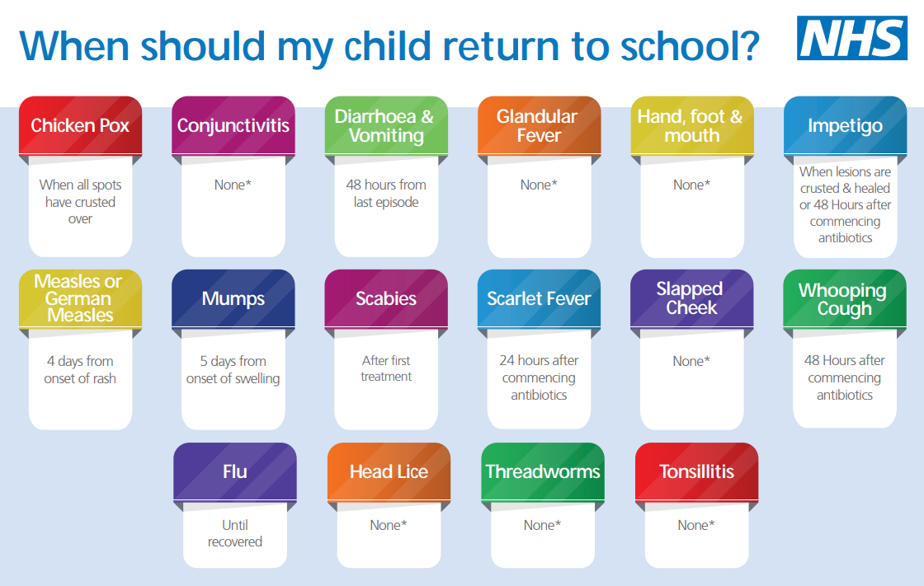
Medical and Dental Appointments
Please let our school office know, in advance, if your child has an appointment during school time. Please also let us know at what time you will collect your child for the appointment and please sign your child out and then sign in again at our school office upon their return to school.

- Lateness and Punctuality

Winnington Park Primary School and Nursery uses a computerised registration system and the register is completed in the morning and afternoon at 9.00am and 1.00pm. A pupil will receive a late mark after 9.00am. All pupils who arrive after 9.00am must report to the office. The school gates open at 8.40am and classroom doors open at 8.50am.

Fifteen minutes after the close of registration a late mark becomes an unauthorised absence. The register will officially close at 9.15am and after this time a child will be coded "U" which statistically counts as an unauthorised absence.

The school office team are responsible for collating attendance records in school and notify the Headteacher if there is any reason for concern. At the end of the year, each child’s attendance is analysed and a copy is given to parents. Where persistent lateness gives cause for concern further action may be taken. In the first instance this will involve a discussion with the parent or carer followed by a letter home if the situation does not improve.

In accordance with the ‘Education (Pupil Registration) (England) Regulations 2006’, if your child arrives after the registers close, they will receive a mark, code U, that shows them to be on site, but this will not count as a present mark and it will mean they have an unauthorised absence. This may mean that you could face the possibility of a Fixed Penalty Notice or other legal action if the problem persists.

Children who are consistently late for school are disrupting not only their own education, but also that of other children. Where persistent lateness gives cause for concern, you will be invited to a meeting to resolve the issues. If there is no improvement following this meeting, further action will be taken which may include referral to external agencies.

Across a year, 15 minutes of lateness each day is the same as missing two whole weeks of school, exemplified in the table below:

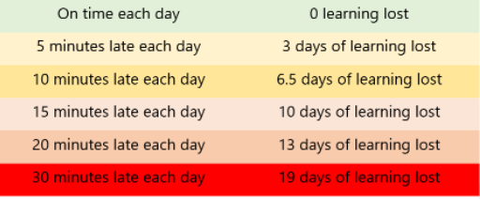

Winnington Park Primary & Nursery School operates a first day response and any absence not reported will trigger a phone call to parents to ascertain the child’s whereabouts and reason for absence. Any safeguarding concerns due to the absence are reported to Designated Safeguard Teacher and Headteacher. If the pupil is absent the following day, school must be informed and the procedures above repeated.

You may approach the school at any time for support and advice if you are having difficulty getting your child to school on time or maintaining regular attendance.

Winnington Park Primary & Nursery School’s expectation of attendance is 96%. Where attendance falls below this, parents will be sent a letter requesting improvement: if attendance falls below 90% school will contact EWO.

Beginning and End of Day Drop off and Collection

Parents/carers/nominated adults should not leave children at school unsupervised before the doors open at 8.50am. The school is not responsible for children before this time. The gates to the school field open at 8.40am.
At the end of the day parents/carers/nominated adults collecting Infants at 3.10pm and Juniors at 3.15pm are responsible for their safety from these times in the school grounds. Parents/carers may wait on the playground.
It is the responsibility of the parent/carer to inform the school if they are unable to collect their child at the above times. This will enable the school to care for the child in such an emergency. Parents/carers will need to inform school who is collecting the child in their place. If it is the first time this person has collected and/or school staff may not know the collecting adult, a password system will be used to confirm their identity. If a longer-term arrangement is made for collection, parents/carers must provide written permission to the school identifying the nominated adult, confirming that they can collect at any time.
To safeguard children, school staff will not send children home with adults that school has not been informed have permission to collect them, even if the nominated adult has been given consent by the parent themselves. Parents/carers will have to be contacted.
The school operates a parent/carer telephone contact register for use in the event of the school requiring contact in an emergency. Parents are required to inform the school of telephone numbers and all changes.

- Unauthorised Absence and Fixed Penalty Notice

An absence may be coded as ‘unauthorised’ if:
    - no reason for absence has been given
    - medical evidence is not received when requested
    - a request for a leave of absence has been unauthorised
    - a pupil arrives at school after registration has closed at 9.15am

Parents/carers should be aware that Winnington Park Primary School and Nursery may contact the Local Authority if a pupil has 10 or more unauthorised absences in the current term with a view to issuing a Fixed Penalty Notice or other legal action. The Fixed Penalty Notice is issued individually to each parent/carer who fails to ensure their child’s regular attendance at school. The Penalty is £60 per parent/carer per child if paid within 21 days rising to £120 if paid within 28 days. Non-payment of the Fixed Penalty Notice may result in prosecution in the Magistrates court (see appendix 1).

- Application for Exceptional Circumstances

The School’s view is that during term time the priority is education. Therefore, following statutory guidance, the school adopts the position that absences will not be granted during term time and will only be authorised in exceptional circumstances.

In September 2013, amendments to the Education (Pupil Registration) (England) Regulations 2006, make it clear that Head Teachers may not grant any Leave of Absence (holiday) during term time unless there are ‘exceptional circumstances’

The Head Teacher and the Governing Body will determine what constitutes an exceptional
circumstance on an individual basis. The fundamental principles defining ‘exceptional’ are: rare, significant, unavoidable (an event that could not reasonably be scheduled at another time) and short.

If parents/carers need to request Exceptional Leave of Absence, they must complete an ‘Exceptional Leave of Absence’ form available from the school office. It should be noted that if any application is declined and absence occurs of a consecutive 5 or more unauthorised days, then school may apply to the Local Authority for a Fixed Penalty Notice to be issued to each parent/carer.

The school’s attendance data, which includes authorisation of leave, is monitored by the Local Authority and the school is held to account for decisions made. The school therefore tries to be consistent in the application of the guidelines we are provided with, as follows:

• If an event can reasonably be scheduled outside of term time then it would not be normal to authorise absence - absence during term time for holidays/vacations is therefore not considered an exceptional circumstance.
• Absences to visit family members are also not normally granted during term time if they could be scheduled for holiday periods or outside school hours. Children may however need time to visit seriously ill relatives.
• Absence for a bereavement of a close family member is usually considered an exceptional circumstance but for the funeral service only, not extended leave.
• Absences for important religious observances can be taken into account but only for the ceremony and travelling time, not extended leave. This is intended for one off situations rather than regular or recurring events.
• Schools have a duty to make reasonable adjustments for students with special educational needs or disabilities. Families may need time together to recover from trauma or crisis.

The following will not be deemed to be exceptional circumstances:
- Family holiday
- Availability of less expensive holiday
- Availability of holiday accommodation
- Parent/carer’s working commitments
- Holiday pre-booked by another family member

A child’s absence during term time seriously disrupts their continuity of learning. Not only do they miss the teaching on the days they are away but are less prepared for the lessons building on that teaching when they return to school. There is a consequent risk of under achievement, which we must seek to avoid. Where requests for absence are not exceptional, parents must complete the absence request form and understand that this absence will not be authorised; both parents with parental responsibility must complete the absence request form to meet our safeguarding children criteria. Information is required, in writing to inform us of the child’s whereabouts and to meet our safeguarding children statutory requirements. Failure to inform the school of absence may lead to the involvement of the Education Welfare Officer.

The Governing Body is responsible for ensuring any attendance issues are dealt with in line with school policy.

- Religious Observance

We recognise that some pupils may need to participate in days of religious observance.
Where a day of religious observance.

- falls during school time and
- has been exclusively set apart for religious observance by the religious body to which the pupil belongs

We ask that parents/carers notify Winnington Park Primary School and Nursery in writing in advance where absence is required due to a religious observance.

- Enforced School Closure

If Winnington Park Primary School and Nursery was forced to close for a period of time, we have the facility to operate an online virtual school. The expectation is children will still engage with ALL activities when work is set. Procedures for online learning will be sent to parents as and when required.

- Impact
All pupils will achieve well by developing knowledge and skills on their journey through school. Due to robust monitoring of attendance, all pupils, including vulnerable children and children with special educational needs and disabilities (SEND), will have fair and equitable access to school in order to achieve the best possible outcomes. Pupils will leave Winnington Park Primary School and Nursery ready for a successful transition toHap secondary education.

The table below sets out the attendance targets and at what stage parents/carers will be contacted about their child’s attendance.
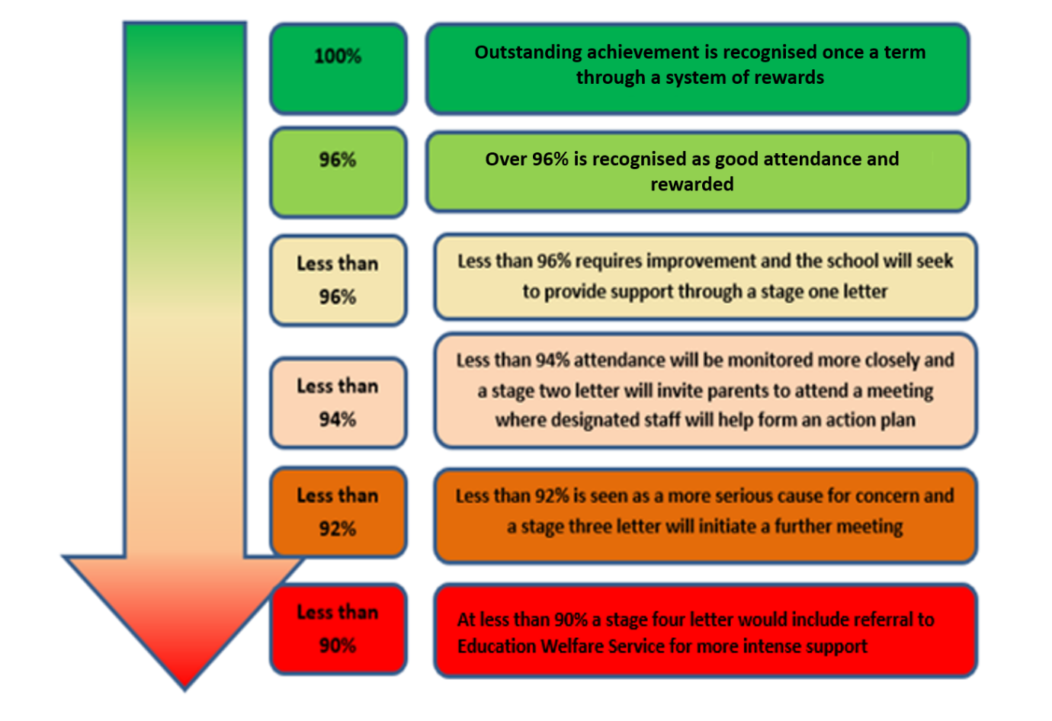
See appendix 2 for further breakdown of missed sessions.

Appendix 1
Cheshire West & Chester
Code of Conduct for Education Fixed Penalty Notice (Unauthorised Leave of Absence & Irregular
Attendance)

1. A Fixed Penalty Notice (FPN) can only be issued in cases of unauthorised absence.
2. A maximum of two FPNs may be issued in an academic year and these FPNs may be issued against each parent/carer of a child. Once two FPNs have been issued, should there be further unauthorised absences, the Local Authority are able to move to prosecution immediately.
3. A FPN may be issued per parent per child.
4. Penalty Notices may be considered appropriate if:
- Unauthorised absences of at least 10 consecutive school sessions (five school days).
- Sessions either side of a weekend or school holiday will be counted as consecutive school days.
- For poorly attending learners, at least 10 sessions (five school days) lost due to unauthorised absence during a school term. These do not need to be consecutive.
- For poorly attending learners, persistent late arrive at school in a term. Persistent means at least 10 sessions of late arrival.
- The presence of an excluded child in a public place in the child’s first five days of exclusion.
6. The school must notify parents of the Attendance Policy and clearly state that parents may receive an FPN for an unauthorised leave of absence relating to holiday in term time.
7. Schools and the Education Welfare Services will take into account any exceptional circumstances when determining whether to issue a FPN.

Appendix 2

What does ‘percentage attendance’ mean?
Parents/carers should be advised that from September 2015 the Government have categorised those pupils who have attendance of 90% and below as ‘Persistent Absence’ pupils (P.A.). RSA will be specifically targeting this cohort of pupils, in an effort to improve their attendance in the future. The table below shows the learning time lost against percentage attendance figures.
Attendance during one school year | Equivalent  Days | Equivalent  Sessions | Equivalent  Weeks | Equivalent Lessons  Missed
95% | 9 Days | 18 Sessions | 1.4 Weeks | 45 Lessons
90% | 19 Days | 38 Sessions | 3.4 Weeks | 95 Lessons
85% | 29 Days | 58 Sessions | 5.4 Weeks | 145 Lessons
80% | 36 Days | 72 Sessions | 7.1 Weeks | 180 Lessons
75% | 48 Days | 96 Sessions | 9.3 Weeks | 240 Lessons

Appendix 3
Absence Codes:
According to the DfE guidance the following codes are used on the register.

Code I | Illness | Schools can request medical evidence from parents/carers if they feel the authenticity of an illness is in doubt.
Code M | Medical or dental appointments | Parents/Carers are encouraged to arrange appointments out of school hours but the school will authorise if confirmation of the appointment is provided.
Code C | Other circumstances | This code will be used for any authorised non-medical reasons for a child’s absence from school, i.e. – family funeral.
Code D | Dual Registered | This code will be used if a pupil is registered at two schools.
Code J | Interview | This code will be used when it has been agreed that the pupil can miss school to attend an interview or entrance exam
Code P | Approved sporting activity | This code will be used in times of approved sporting activities in school times, i.e. – training sessions, trials and sporting events.
Code R | Religious Observation | This code is used to cover major religious festivals during term-time. The school will only authorise one day absence for religious events.
Code V | Educational visits and trips
Code W | Work Experience
Code G | Family holiday not authorised by the school or in excess of agreed period
Code U | Arrived late to school after 9.30am
Code N | Reason for absence not yet provided
Code O | Absent from school without authorisation
Code X | Not required to be in school (not compulsory school age)

Guidance for schools – Attendance case working. (School only)

These stages should be followed once a pupil has reached 10 sessions of unauthorised absence and the school is considering the Education Welfare Service’s involvement as current strategies are not improving attendance.

Stage 1 (within 30 days)

- Ensure usual attendance policy procedures are being followed
- Continue normal first day contact etc.
- Conduct investigative safeguarding home visits.
- Gather information from teaching and support staff regarding the pupil’s strengths and needs – this may include a round robin
- Meet with pupil to elicit their views about school (eg. what is working well / working less well)
- Develop a shared action plan in collaboration with parents / carers, pupils and key staff (informed by assessments and to address specific factors underlying non-attendance)
- Continue to follow assess, plan, do and review cycles focussed on targeted intervention and support – eg. Support and Attendance Plan
- Make an initial single assessment (simplified TAF assessment)
- Refer to other agencies as appropriate (e.g iART)
If parent/carer does not engage with support offered
- Arrange an Attendance Panel Meeting to discuss barriers to attendance, record the voice of the child and complete and ESO checklist
- Consider an irregular attendance FPN (10-26 sessions unauthorised)
- Consider a first warning letter for prosecution for more entrenched cases (26+ sessions)

Stage 2 (within 60 days)

- Continue with usual contact in line with attendance policy
- Conduct further home visits
- Discuss case with attendance lead in school
- Consider Attendance Planning Meeting if there is no improvement following the prosecution first warning letter
- Issue a final warning letter if no improvement following the Attendance Planning Meeting
- Consult with Education Welfare Officer to support in preparing witness statement and exhibits of evidence

Stage 3 (within 90 days)

- EWO will support in setting up Court File as follows:
- Statement of evidence S9
- Exhibits (labelled and numbered)
- Head teacher certificate
- Recent registration certificate

Please note, each section says WITHIN the time scale, so you don’t have to wait until 30 days have passed to take action.

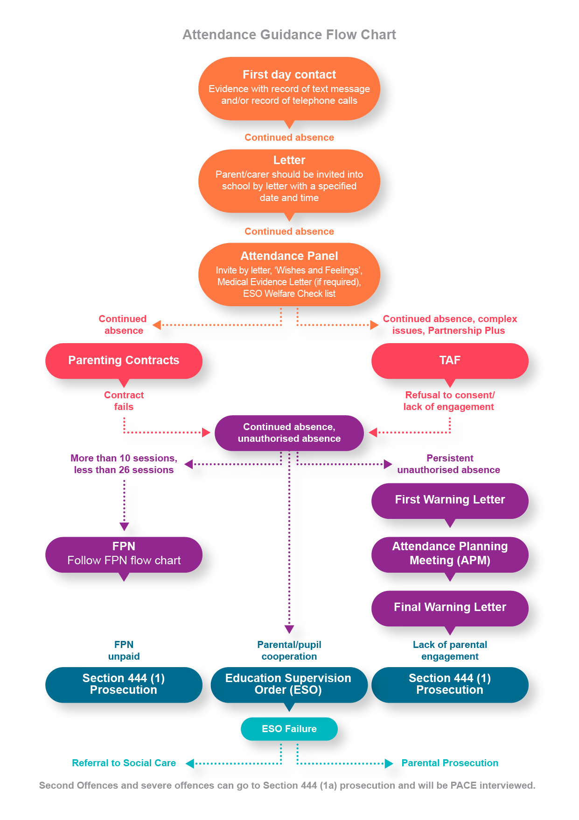

Emotionally Based School Non-attendance (EBSN)
Emotionally Based School Non-attendance (EBSN) is a term used to describe the needs of CYP who struggle to attend school due to underlying emotional based needs, such as anxiety, unhappiness and despair. These CYP may be reluctant to leave home and can present high levels of distress in response to parents’ attempts to get them to school. This can result in prolonged absences from school.
EBSN is complex and multifaceted, requiring a holistic approach to assessment and intervention. Good practice guidance emphasises the importance of early identification and intervention to support the needs of CYP who may struggle to attend school, developing a SMART support plan, with timely review processes (CW&C, 2018).
The EBSN framework is embedded within the school’s Attendance Policy and we use many of the tools and resources to underpin our early identification of need and targeted support and intervention approach.

Stage 1 letter

Our ref: XXXX
Date
Name
Address

Dear <insert parent/carer name>

RE: Stage 1 Attendance letter
<insert pupil name>
Re: Attendance – XX%

At Winnington Park Primary School and Nursery we have a strong focus on attendance to ensure that all pupils make excellent progress and achieve their very best potential.

Our records show that <insert pupil name> attendance is XX%. (Please see enclosed attendance record). As this is just falling below the national expected minimum of 96% we are therefore writing to offer additional support and to open communication in the hope that we can improve their attendance and ensure that it improves.

Good attendance is key to ensuring that pupils progress well at school. In addition, your child’s attendance record has to be conveyed in any future reference provided by the school.
We are hopeful that your child’s attendance will improve and we wish to offer our support and ask that you communicate to us any provision or assistance which you feel may be beneficial or communicate any reasons why you feel that improved attendance may be difficult so that we can work together in supporting your child.

The aim is for your child’s attendance to improve within the next 4 weeks in order to avoid having to issue a continued attendance concern letter. If you would like to discuss anything in relation to this letter, please do not hesitate to contact me.

Yours sincerely,

Name
Position

Medical evidence letter

Our ref: XXXX Date
Name
Address
United Kingdom

Dear <insert parent/carer name>

Re: Medical Evidence
<insert pupil name> Re: Attendance – XX%

Winnington Park Primary School and Nursery places great emphasis upon every student achieving their full potential. It is important therefore that every student attends the school regularly and participates in the schooling that is offered if they are to make good progress and benefit from the opportunities that school offers.

It is expected that parents/carers support their child by complying with the law which imposes a duty on parents/carers to ensure that their son/daughters are properly educated.

I am aware that there have been reasons provided for these absences however to enable us to authorise any future absences due to illness medical evidence will be required.

This can be in the form of:
- Copy of prescription relating to the illness
- A dated note from the GP’s receptionist confirming your visit to the GP
- A medical appointment card
- Evidence of medical prescribed by the GP

May I remind you that after 10 sessions (5 days) of unauthorised absence you may receive a fixed penalty notice warning.

If there is anything that you feel the school should be aware of, or that I can help you with, I would be grateful if you could telephone me at school to discuss this further.

Yours sincerely,

Name
Position

Stage 2 letter

Our ref: XXXX Date
Name
Address
United Kingdom

Dear <insert parent/carer name>

Re: Invitation to Stage 2 Attendance Action Plan meeting
<insert pupil name> Re: Attendance – XX%

At Winnington Park Primary School and Nurserywe have a strong focus on attendance to ensure that all pupils make excellent progress and achieve their very best potential.

Our records show that <insert pupil name> attendance is XX%. (Please see enclosed attendance record). As this is now below the national expected minimum of 96% and a previous letter has been issued to offer support, we are therefore now writing to offer further provision and to strengthen communication by inviting you to come into school on <day, date and time> when we will discuss the matter and form an Action Plan.

If you would like us to attend the family home or meet at another location please advise us at your earliest convenience.

I look forward to seeing you at this meeting. If this is inconvenient, please contact me as soon as possible to rearrange a more suitable time.

Yours sincerely,

Name
Position

Stage 3 letter (a)

Our ref: XXXX
Date
Name
Address
United Kingdom

Dear <insert parent/carer name>

Re: Invitation to Stage 3 Attendance planning meeting after no response
<insert pupil name> Re: Attendance – XX%

I am writing to you regarding the previous letter I sent out requesting a meeting regarding <insert pupil name> attendance record. Unfortunately, I have had no response.

Our records show that <insert pupil name> attendance is XX%. (Please see enclosed attendance record). This is below the national expected minimum of 96% and is therefore a cause for concern.

You are invited to attend a meeting to be held at <insert place> on <day, date and time>.

The purpose of the meeting is to discuss a way forward in improving your <insert pupil name> attendance. A representative of the Local Authority may be present at this meeting to ensure that we can form a robust action plan and make rapid progress due to the fact that the previous meeting has not been attended.

You are urged to attend this meeting as failure to do so may result in a fixed penalty notice being issued against you.

Yours sincerely,

Name
Position

Stage 3 letter (b)

Our ref: XXXX
Date
Name
Address
United Kingdom

Dear <insert parent/carer name>

Re: Invitation to Stage 3 Attendance planning meeting after no improvement
<insert pupil name> Re: Attendance – XX%

I am writing to you regarding the previous meeting regarding <insert pupil name> attendance record. Unfortunately, their attendance has not improved and there is now a more serious concern about their welfare and educational needs being met.

Our records show that <insert pupil name> attendance is XX%. (Please see enclosed attendance record). This is now well below the 96% expected minimum and is therefore a major cause for concern.

You are invited to attend a meeting to be held at <place> on <day, date and time>.
The purpose of the meeting is to discuss a way forward in improving your <insert pupil name> attendance.

A representative of the Local Authority may be present at this meeting to ensure that we can form a robust action plan and make rapid progress due to the fact that your child’s attendance is not improving.

You are urged to attend this meeting as failure to do so may result in a fixed penalty notice being issued against you.

Yours sincerely,

Name
Position

Letter after Stage 3 – Attendance Action Plan

Our ref: XXXX
Date
Name
Address
United Kingdom

Dear <insert parent/carer name>
<insert pupil name> Re: Attendance – XX%

I am writing to you regarding the recent meeting which we had concerning <insert pupil name>
attendance at the <insert school>.

I have enclosed a copy of the Action Plan for your information and attention.

May I take this opportunity to inform you that: under Section 444 of the Education Act 1996, you have a legal responsibility to ensure that <insert pupil name> attends the Winnington Park Primary School and Nurseryregularly. Failure to do so may lead in legal action being taken against you by the Local Authority resulting in prosecution.

Thank you for attending the recent meeting; it is only by all working together that we can achieve the best possible educational and social outcomes for our pupils.

Yours sincerely,

Name
Position

Letter after failure to attend Stage 3 meeting
Our ref: XXXX
Date
Name
Address
United Kingdom

Dear <insert parent/carer name>
<insert pupil name> Re: Attendance – XX%

As you failed to attend a meeting on <day, date and time>, you are now invited to attend a meeting to be held at the Winnington Park Primary School and Nurseryon <day, date and time>.
The purpose of the meeting is to discuss a way forward in improving your child’s attendance. A representative of the Local Authority will be present at this meeting.
You are urged to attend this meeting as failure to do so may result in a fixed penalty notice being issued against you. I enclose a copy of your child’s registration certificate.

Yours sincerely,

Name
Position

Stage 4 letter: still no improvement after Stage 3 meeting and plan (first warning letter)

Our ref: XXXX
Date
Name
Address
United Kingdom

Dear <insert parent/carer name>
<insert pupil name> Re: Attendance – XX%

I am writing to express my concern regarding <insert pupil name> continued irregular attendance. According to the class register, between <date> and <date> <insert pupil name> has been marked absent for XX sessions, of which XX were authorised and XX were unauthorised. <insert pupil name> has completed XX full weeks in school out of a possible XX weeks. A copy of the percentage attendance register is enclosed.
The Winnington Park Primary School and Nurseryhas made efforts to engage with you in attempting to improve this situation but despite this there has been no improvement in <insert pupil name> attendance.

Such attendance is not acceptable and I must remind you that S.444, Education Act 1996 requires you to make sure that your child comes to school, on time, every time the school is open. I am writing this letter to give you an opportunity to make sure that from now on and in future, your child attends school regularly.
Failure to do so may result in the Local Authority taking one of the following actions:
a) Initiating legal proceedings in the Magistrates Court under S.444(1) Education Act 1996. If convicted under this section, you may be fined up to £1,000.
b) Initiating legal proceedings in the Magistrates Court under S.444(1A) Education Act 1996. If convicted of this offence you may be fined up to £2,500 or be sent to prison for up to 3 months or both.
I now look forward to your co-operation in ensuring an immediate and sustained improvement in your child’s school attendance.
If you wish to discuss this matter, please contact me at your earliest convenience.

Yours sincerely,

Name
Position

Final warning letter

Our ref: XXXX
Date
Name
Address
United Kingdom

Dear <insert parent/carer name>
<insert pupil name> Re: Attendance – XX%

On <insert date>, we wrote to you concerning <insert pupil name> irregular attendance at <insert school>.

Unfortunately, I now have to contact you again as <insert pupil name> has continued to be absent from school during the last XX weeks.

Obviously, such a record is not acceptable, and I now have to warn you that unless there is an immediate improvement in <insert pupil name> school attendance, the Local Authority will have no option but to instigate one of the following options:

a) Initiating legal proceedings in the Magistrates Court under S.444(1) Education Act 1996. If convicted under this section, you may be fined up to £1000.

b) Initiating legal proceedings in the Magistrates Court under S.444(1A) Education Act 1996. If convicted of this offence you may be fined up to £2,500 or be sent to prison for up to 3 months or both.

Please contact me to discuss.

Yours sincerely,

Name
Position

