Winnington Park Primary School and Nursery

English Policy

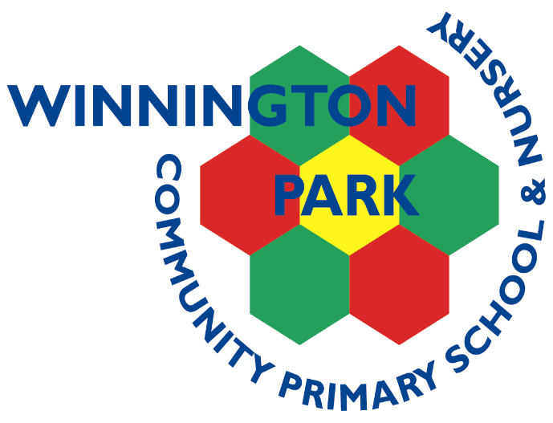

Completed by: Bria Hall, Anne Jurgis and Jo Flower

Updated: January 2024

Review date: January 2025
Our School Vision

Our vision is of a community whose members: children, parents, teachers and staff work collaboratively towards achieving an exciting and inclusive school, with high expectations and standards for all, within a happy, caring and secure environment.

Our Curriculum Vision

At Winnington Park Community Primary School and Nursey we aim offer a creative and inclusive Curriculum which inspires, engages and challenges and in which children are partners in their own learning.

INTENT

We ensure that children are given opportunities to widen their knowledge and understanding of the world and learn and apply skills which will make them successful learners for life as well as enhancing their spiritual, moral, social and cultural development.

Children will become confident, independent and resilient learners who are willing to take risks. They will have high aspirations and be proud of their achievements. We aim to give everyone the opportunity to fulfil their highest potential, both academically and in respect of their wider interests and talents.

Our curriculum has clear end points and our lessons are sequenced so children’s learning builds towards these. The children’s new knowledge and skills builds on what they have been taught before and is designed for the children, families and community of Winnington Park.

IMPLEMENTATION

Our children learn through a knowledge-based curriculum which develops children’s skills. We endeavour to engage our children and completely immerse them in their learning. Topics are progressive whilst being inclusive and challenging. They provide children with the knowledge and skills needed for the next stage in their learning and later life.

We celebrate and value all subjects and provide opportunities to apply key skills in all areas of learning. We have high expectations of achievement, progress, behaviour and presentation. Our children enjoy developing their learning through enhanced projects such as writing and reading weeks, art workshops, trips and residentials.

IMPACT

The impact of our curriculum ensures children are prepared for the next stage of learning and later life. Children who attend Winnington Park achieve well and are equipped with the knowledge and cultural capital they need to succeed in life.

Aims

The overarching aim for the teaching of English at Winnington Park Primary School is to implement the aims of the National Curriculum and to promote high standards of language and literacy by equipping pupils with a strong command of the spoken and written word. At Winnington Park Primary School, we want to foster and develop children’s love of literature through widespread reading for enjoyment. The National Curriculum for English aims to ensure that all pupils:

• read easily, fluently and with good understanding
• develop the habit of reading widely and often, for both pleasure and information
• acquire a wide vocabulary, an understanding of grammar and a knowledge of linguistic conventions for reading, writing and spoken language
• appreciate our rich and varied literary heritage
• write clearly, accurately and coherently, adapting their language and style in and for a range of contexts, purposes and audiences
• use discussion in order to learn; they should be able to elaborate and explain clearly their understanding and ideas
• are competent in the arts of speaking and listening, making formal presentations, demonstrating to others and participating in debate.

Statutory requirements

Statutory requirements for the teaching and learning of English are laid out in the National Curriculum English Document (2014) and in the Early Years Foundation Stage Profile.

Planning and progression

English is a core subject in the National Curriculum. We use the National Curriculum 2014 as a basis for implementing the statutory requirements of the programme of study for English.

At Winnington Park Primary School, each term has an overarching theme of Science, Geography or History. These themes are then used by teachers to inspire all curriculum planning, and where possible English is taught in a cross curricular way.

Curriculum planning is in three phases (long, medium and short- term).

The National Curriculum details what we teach in the long term.

Our medium-term plans, which we also base on the National Curriculum, give details of the main teaching objectives for each term.

These plans define what we teach and ensure an appropriate balance and distribution of work across each term.

Class teachers complete daily lesson plans for the teaching of English including reading, writing phonics, spelling and grammar. These list the specific learning objectives for each lesson and give details of how the lessons are to be taught. They also include details of what each group of children will be learning.

Teaching and Learning, Speaking and Listening

The Four Strands of Speaking and Listening: speaking; listening; group discussion and interaction, and drama permeate the whole curriculum. Interactive teaching strategies are used to engage all pupils in order to raise reading and writing standards. Children are encouraged to develop effective communication skills in readiness for later life.

Reading

At Winnington Park we recognise the importance of reading and staff are committed to instilling an understanding of the value of reading to the children that we teach.

Guided Reading

Early Years Foundation Stage

In Reception, children take part in Reading Practice sessions as part of the Little Wandle Phonics programme.

Key Stage One and Key Stage Two

In Year 1, children take part in Reading Practice sessions as part of the Little Wandle Phonics programme.

Teachers in Years 2 to 6 plan Guided Reading using the school planning carousel format with objectives from the National Curriculum and the Content Domains for the appropriate age group. Groups are reviewed and evaluated regularly by the class teacher and appropriate changes are made.

The carousel planning includes weekly opportunities for Whole Class Guided Reading, Guided Reading sessions with the class teacher and/or teaching assistant, and follow up activities that focus upon developing and exploring vocabulary, comprehension work and reading for pleasure through independent reading and visits to our school libraries.

Guided Reading is evidenced in pupils’ reading diaries. Other carousel activities are evidenced in pupil’s guided reading books.

Whole Class Reading

Whole Class Reading is delivered across EYFS, Key Stage 1 and 2 on a weekly basis. During these sessions, teachers model prosody, reading strategies and how to answer a range of comprehension questions across the Content Domains.

Independent Reading

Home-School diaries are used throughout the school and are brought into school every day. Pupils are expected to read at home every day and this is to be evidenced by parents/ an adult at home at least 3 times per week. Teachers monitor children’s book choices and frequency of reading.

Decodable Texts

Children in EYFS & Year 1 have fully decodable texts that match their current phonic phase and the GPCs that they have been taught. Only when ready do Year 2 children begin to take home Book Banded texts rather than or in addition to decodable texts. Decodable texts are also available to children in Key Stage 2 who need support with phonic development.
Book Bands

At Winnington Park we use a variety of colour banded reading scheme and non-reading scheme books. Banding allows children to identify books to enable them to access progression through books of increasing complexity.

All classes are have stories read to them throughout the year. The staff makes use of the Education Library Service to supplement school resources for Guided Reading, class stories and topic books. All classes have an attractive, well-resourced reading area where reading is promoted, and there are libraries and reading areas throughout the school. This includes guest readers from our wider community, parent reading cafes, reading challenges and a book fair.

Writing

At Winnington Park, writing is taught through a mixture of shared, guided and independent writing. All year groups use the school literature spine and the Winnington Park Primary School English Long Term Plan to ensure that children are introduced to a wide variety of texts and cover a range of genres. Children are given the opportunity to write on a daily basis through sentence work, short burst writing and extended writing. All year groups will cover fiction, non-fiction and poetry genres each half term which are outlined on the Winnington Park Long Term English Plan. To ensure consistency throughout the school, teachers in Key Stages 1 and 2 must adopt the following approach, which is based upon key principles from Talk for Writing, when teaching a unit of work:

- Text is introduced to the children and explored through book talk and drama. Children explore the vocabulary, spelling patterns and the effect that the writer is trying to create as well as the purpose of the piece of writing. This can be linked to guided reading sessions.
- Over the period of the unit, children learn either the whole text, a shortened version of the text, or a section of the text through daily retelling, role play and story maps (this depends on the year group, for example KS1 will learn to retell the whole story whereas KS2 might learn sections rather than the whole text).
- Throughout the unit, banks of words, phrases and ideas are recorded and displayed in the class on washing lines/working walls to scaffold the children’s work.
- Short burst writes are done daily. These lessons focus on teaching key knowledge and practising key skills which the children will need to write their final piece at the end of the unit. Guided and shared writing is key to support children at varying levels depending on their needs.
- The text is ‘boxed up’ into its key elements to provide generalisations which can be applied to other texts. In addition, toolkits are constructed focusing on how the writer creates the desired effect (this can be done through text marking and highlighting key features).
- Using the learned text structure, children begin, through shared writing, to create new individual and class versions of the text (innovation stage).
See Appendix A for an overview of the teaching sequence across the school.

Phonics and Spelling

Aims

At Winnington Park Primary School, we promote high standards of language and literacy by equipping pupils with a strong command of the spoken and written word. We prioritise spelling as we believe it is a key skill which enables pupils to speak and write fluently so that they can communicate their ideas and emotions to others, and through their reading and listening, others can communicate with them.

Spelling is the process or activity of writing or naming the letters of a word. For pupils to develop spelling skills and implement strategies, teachers need to teach students appropriate strategies to accurately spell familiar and unfamiliar words when composing texts. Therefore, at Winnington Park Primary School, we teach and practise spellings daily across Key Stage 1 and 2. Spellings and phonics (in Key Stage 1) are taught in an explicit, systematic, functional and contextual way and are directly linked to the National Curriculum.

Phonics

Phonics at Winnington Park Primary & Nursery School, synthetic phonics is taught as the main approach to early reading. Daily discrete phonics sessions are taught from Nursery through to Year 1 using the “Little Wandle” programme as well as phonics / spelling interventions continuing throughout Year 2 – Year 6.

“Little Wandle” is divided into six phases, with each phase building on the skills and knowledge of previous learning. There are no big leaps in learning. Children have time to practise and rapidly expand their ability to read and spell words. They are also taught to read and spell ‘tricky words’. These are words taught at each phase which cannot be phonetically sounded out, and are taught through sight recognition for example, “said, the, was”.

Phase one begins in Nursery and provides the foundation for the learning of systematic phonics. During this phase especially, we plan activities that will help children to listen attentively to sounds around them, such as the sounds of their toys and to sounds in spoken language. We teach a wide range of nursery rhymes and songs as well as sharing high quality stories. This helps to increase the number of words they know – their vocabulary – and helps them talk confidently about books. The children learn to identify rhyme and alliteration.

A phonics session takes place at least daily in EYFS, Year 1, 2 and in Key Stage 2 where appropriate involving lots of speaking, listening and games. The emphasis is on children’s active participation and the children focus on the phase that is suited to their individual needs. They are encouraged and taught how to use their phonic knowledge for reading and writing activities and in their independent play.

At each phase, children are taught to recognise individual sounds, pairs and clusters of letters. In phonic sessions children are taught to recognise letters, understand the sounds they make and then blend them together to create words and to segment them to spell words. The sounds are taught in a specific order (not alphabetically). This enables children to begin building words as early as possible.

Spelling

EYFS

In the Early Years Foundation Stage, Little Wandle is the phonics scheme which is implemented and taught. Opportunities are provided to practise reading and then writing applying the phonics they have been taught. Following ongoing assessments, children who are at risk of falling behind are identified and take part in daily catch up sessions.

Year 1

In Year 1, children will have spelling homework which will be in line with the National Curriculum and Little Wandle phonics scheme. During Little Wandle phonics sessions, children have the opportunity to spell three focus words within each session.

Children will be sent six spellings and will be taught the rules and sounds specifically in phonics and English lessons. Children will write three of the spelling words in their handwriting books on the day of their spelling quiz.

Following ongoing assessments, children who are at risk of falling behind are identified and take part in daily catch up sessions.

Year 2

After the Year 1 phonics screening check, teachers and Senior Leaders will target the children who did not pass the check with additional phonics support. This will take place at least three times a week and spelling homework may be differentiated according to individual needs and circumstances. These children will still take part in at least two spelling lesson with their class. This is dependent on the needs of the specific cohort and is reviewed yearly with SLT.

Year 2 children will have spellings taught explicitly daily through the spelling scheme, Rising Stars as well as common exception words taught through games or activities. Phonics catch up sessions will be additional to these lessons and will be delivered three times a week, based on the needs of the cohort. This can be delivered through activities and games. All children in Year 2 will be part of this additional phonics catch up sessions.
During handwriting sessions, children will apply High Frequency and Common Exception Words.

Children will have ten spellings to learn, which will incorporate the National Curriculum spelling words being taught that week as well as two High Frequency or Common Exception Words. In Autumn, the children will be quizzed on three random words from their spelling list. After Christmas, children will then be tested on three random words within dictated sentences. This will ensure other spelling rules and misconceptions can be addressed and practised.

Year 3-6:

In Key Stage Two, children will have five sessions, where they will deliver three Rising Stars lessons based on the National Curriculum and two grammar lessons prior to the English lesson. Grammar and spelling objectives can also be incorporated throughout English lessons.

Catch up phonics programmes are delivered outside spelling and English lessons to support children who may need it. This is reviewed by SLT regularly.

Children will have a spelling quiz on a Friday, where they will have dictated sentences (Year 3 and 4, four words and Year 5 and 6, five words) within their handwriting session at the start of English.

Whilst phonics is our primary method of teaching reading, we do recognise that some children will need additional support using different teaching strategies.

Handwriting

Aims

Handwriting is a skill which, like reading and spelling, affects written communication across the curriculum. Children must be able to write with ease, speed and legibility. Cursive handwriting teaches pupils to join letters and words as a series of flowing movements and patterns. Handwriting skills should be taught regularly and systematically.

Our aims in teaching handwriting are that the pupils will:

- Achieve a neat, legible style with correctly formed letters in accordance with the cursive font.
- Develop flow and speed.
- Eventually produce the letters automatically and in their independent writing.
Implementation
In order to achieve these aims, the following principles are followed:
Teaching and Learning
Children should experience coherence and continuity in learning and teaching across the school. Develop a recognition and appreciation of pattern and line and be given support in finding a comfortable grip. Understand the importance of clear and neat presentation in order to communicate meaning clearly. Encouraged to take pride in the presentation of their work and therefore study handwriting with a sense of enjoyment and achievement.
Be supported in developing correct spelling quickly through a multi-sensory approach to handwriting. Shown how to be able to write quickly to aid expressing themselves creatively and imaginatively across the curriculum and for a range of purposes. Encouraged use their skills with confidence and pride in real life situations.

Outlined below is the key teaching for each year group:

EYFS

Early Years Children take part in a range of activities through adult led and planned continuous provision to develop their fine and gross motor-skills and recognition of patterns including ‘Dough Disco’, Squiggle While You Wiggle, Pen Disco and Finger Gym, for example, and other multi-sensory activities. Children should begin to learn how to correctly hold a pencil. Then how to use a pencil, and hold it effectively to form recognisable letters most of which are correctly formed. They should be given the opportunities to develop their handwriting to their full potential at that age. Teachers will follow the Little Wandle Scheme daily for letter formation and will print letters.

Key Stage 1

Children will continue to develop fine and gross motor-skills with a range of multi-sensory activities. Handwriting should be discussed within and linked to phonics sessions (Little Wandle). Key Stage 1 practise handwriting daily in their handwriting books.
In Year 1, teachers follow Little Wandle Scheme for letter formation. Handwriting and phonics are taught separately. Handwriting is taught in letter families (curly, straight, bumpy, zig-zag) and emphasis is on teaching upper and lower case letters. Links to handwriting are made through teaching.

In Year 2, teachers will ensure pupils have the correct letter formation. Those that are ready can begin to join letter families during spelling sessions. Throughout the year, the teacher will start off printing letters before progressing to joining letter families. There will be a mixture of printed letters and joined handwriting. Key vocabulary: ascender, descender, lead out, body of the letter, join and size.

Key Stage 2

During this stage, the children continue to have direct teaching and regular practice of handwriting. We aim for them to develop a clear, fluent style and by the end of Year 6 be able to adapt their handwriting for the for different purposes, such as: a neat, legible hand for finished, presented work, a faster script for note making and the ability to print for labelling diagrams etc. All handwriting is to be completed in English books at the start of each English lesson on handwriting paper. Handwriting is linked to spellings.

In Year 3, pupils will begin the year with handwriting practise in pen and English/Topic work in pencil. Pupils will transition to a pen as a cohort in Autumn 2, when ready. The focus for Autumn 1 is letter formation, diagonal and horizontal joins (linked to letter families). In Autumn 2, teachers teach through a range of strategies such as dictation, modelling sentences structure and incorporating spelling words. Spring / Summer is focused on practising the correct letter formation. Key vocabulary: diagonal, horizontal, relative size, legibility, consistency, quality, down-stroke and upstroke.

In Year 4, pupils continue practising daily handwriting in English books at the beginning of each lesson. Teachers introduce joining letters ‘s’, ‘b’ and ‘p’. teachers teach using a range of strategies with handwriting linked to spelling. Key vocabulary: legibility, consistency, relative size, accuracy and regular joining.

In Years 5 and 6, pupils continue practising daily handwriting in English books at the beginning of each lesson, linked to the pupils spelling and grammar objectives. Majority of all letters are joined. Key vocabulary: legibility, consistency and fluency.

See Appendix A for examples of letter formation and joins.

Provision for left-handed children

At least 10% of the population are left-handed, the majority of whom are boys. All teachers are aware of the specific needs of left-handed pupils and make appropriate provision:

- paper should be positioned to the left for right handed pupils and to the right for left handed pupils and slanted to suit the individual in either case;

- pencils should not be held too close to the point as this can interrupt pupils’ line of vision;

- pupils should be positioned so that they can place their paper to their left side;

- left-handed pupils should sit to the left of a right-handed child so that they are not competing for space;

- extra practice with left-to-right exercises may well be necessary before pupils write left-to-right automatically.

- Teachers are aware of the fact that it is very difficult for left-handed pupils to follow handwriting movements when a right-handed teacher models them. Teachers demonstrate to left-handers on an individual or group basis, even if the resulting writing is not neat.

Equal Opportunities / SEND

Equality of opportunity at Winnington Park Primary School means that all children, taking account of gender, age, ability, disability, ethnic origin, faith, culture, social circumstances and sexual orientation have full access to all the curricular, pastoral and social opportunities offered by our science curriculum. We recognise and provide suitable learning opportunities for all children by matching the challenge of task to the child. This is achieved through a range of teaching and learning strategies. Some lessons have differentiated group work; while in others we ask children to work from the same starting point before moving on to develop their own ideas. SEND Children The SEND Co-ordinator will liaise with class teachers to ensure that the individual needs of pupils with special needs are met and that appropriate targets are set and are regularly reviewed. Teachers may provide support in English through: • Using texts that children can read and understand
• Using visual and written materials in different formats
• Using ICT, other technological aids and audio materials
• Using alternative communication such as signs and symbols

Intervention Programmes

Where the class teacher feels a pupil may benefit from some form of intervention they will liaise with the Special Educational Needs Co-ordinator. Our provision addresses the needs of both individual and groups of children. Support may be short or long term, individual or within a group.

Assessment of pupil will take place before and at the end of intervention. This will initially provide strengths and weaknesses information, and also measure progress over period of intervention.

Assessment, recording and reporting

The progress of all pupils is monitored from their starting points. Progress and attainment is discussed and evaluated termly at pupil progress meetings and actions are planned for those pupils who are not on track for expected attainment. Work will be assessed in line with the Assessment Policy and Marking Statement of Practice (see separate assessment documents). Marking will vary according to individual needs, age and purpose of work set and will follow the school Marking Policy We use a range of Formative & Summative assessment at Winnington Park: Formative assessment- monitors pupils’ learning and provides ongoing feedback for both pupil & teacher.

• Whole Class Reading notes (WCR)
• Guided Reading notes(GR)
• 1:1 Reading notes
• Phonics lesson notes
• Responses during story time
• Intervention reports/feedback Writing
• Daily work marking/observation
• PIRA tests- scores & analysis
• Benchmarking- level & analysis
• Phonic Screening
• Intervention reports/feedback
• SATS
• Phonics tracking

Appendix A
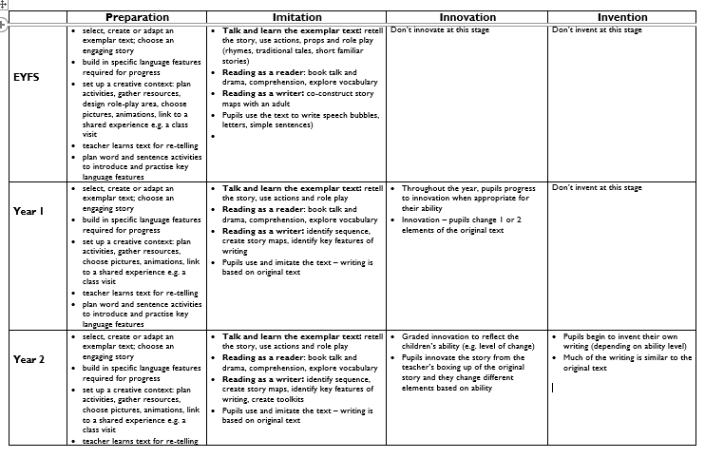

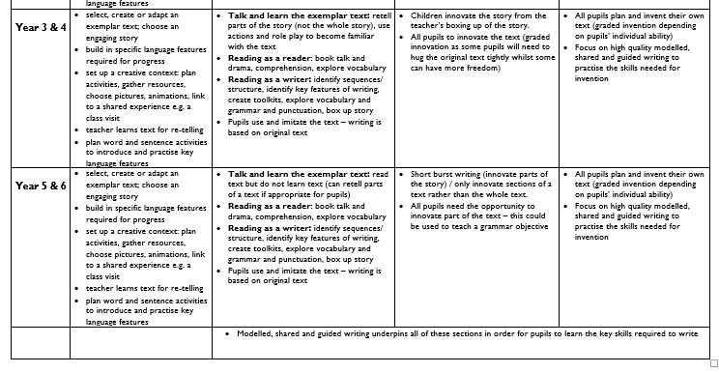
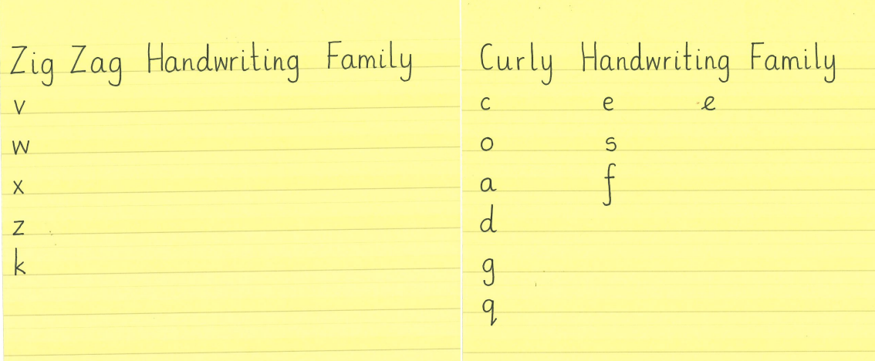
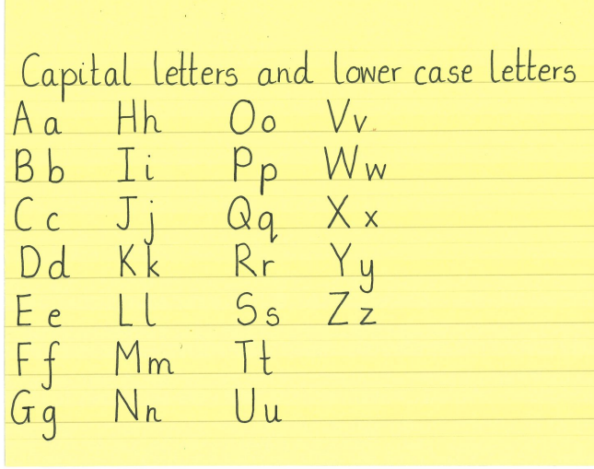
Appendix B
