Times Tables Homework Year 4 Summer 1
Practice your multiplication tables every day. Children in Year 4 are expected to know every single multiplication and division fact up to 12X12! Every Friday you will complete a Mad Minute multiplication test – try and beat your score.
We will focus on learning the timetables below in lessons each week so practice them at home!
Week beginning 17th April  Review all x tables up to 12 x 12 . | Week beginning 24th April  Review all x tables up to 12 x 12 . | Week beginning 1st May  Review all x tables up to 12 x 12 . | Week beginning 8th May.  Review all x tables up to 12 x 12 . | Week beginning 15th May.  Review all x tables up to 12 x 12 . | Week beginning 22th May  Review all x tables up to 12 x 12 .
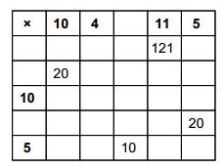 | 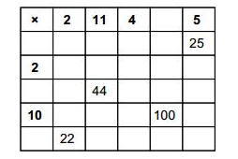 | 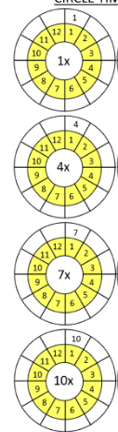 | 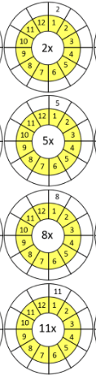 | 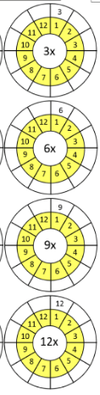 | 