Times Tables Homework Year 4 Summer 2
Practice your multiplication tables every day. Children in Year 4 are expected to know every single multiplication and division fact up to 12X12! Every Friday you will complete a Mad Minute multiplication test – try and beat your score.
We will focus on learning the timetables below in lessons each week so practice them at home!
Week beginning 5th June  Review all x tables up to 12 x 12 . | Week beginning 12th June  Review how to divide. | Week beginning 19th June  Review how to divide with remainders. | Week beginning 26th June.  Review finding a fraction of a number. | Week beginning 3rd July.  Review rounding numbers and decimals. | Week beginning 10th July.  Review multiplying numbers.
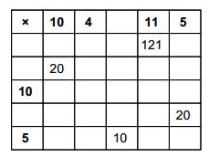 | 69 ÷ 3 = 23  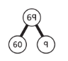  60 ÷ 3 = 20  9 ÷ 3 = 3  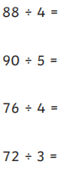  Answer the questions below using the model above: | 85 ÷ 4 = 21 r 1  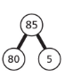  80 ÷ 4 = 20  5 ÷ 4 = 1 r 1  Answer the questions below using the model above:  92 ÷ 3 =  84 ÷ 5 =  45 ÷ 10 =  81 ÷ 6 = | Find $\frac{1}{8}$ of 24 = 3  24 ÷ 8 = 3  So, $\frac{1}{8}$ of 24 = 3  Find $\frac{3}{8}$ of 24 =  24 ÷ 8 = 3  3 x 3 = 9  So, $\frac{3}{8}$ of 24 = 9  Answer the questions below using the model above:  $\frac{3}{4}$ of 36 =  $\frac{4}{5}$ of 20 =  $\frac{3}{10}$ of 70 =  $\frac{5}{6}$ of 12 = | Maths rule – if the digit is 5 or above you round up to the next place value. If it 4 of below you round down to the place value below.  -Rounding to the nearest 10 – Look at the ones digit.  -Rounding to the nearest 100 – look at the tens digit.  -Rounding to the nearest 1000, look at the hundreds digit.  -Rounding to the nearest whole number (Decimals) – Look at the number after the decimal point.  Answer the questions below using the example to help.  Round these numbers to the nearest 10, 100 and 1000: 17, 56, 732, 1043, 875, 2753, 6541, 763  Round these decimals to the nearest whole number:  0.2, 6.5, 8.7, 56.3, 92.1, 89.7, 0.02, 1.75 | 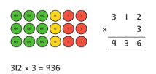  Answer the questions below using the model above:  - 36 x 6 =  - 241 x 3 =  - 645 x 6 =  - 580 x 2 =  - 156 x 9 =

