Key Stage 1 Reading Vipers- questions to develop comprehension

Vocabulary
• What does the word ………. mean in this sentence?
• Find and a word which means ……….
• What does this word or phrase tell you about ………?
• Which word in this section do you think is the most important? Why?
• Which of the words best describes the character/setting/mood etc.?
• Can you think of any other words the author could have used to describe this?
• Why do you think ………. is repeated in this section?

Infer
•Why was……. feeling……..?
• Why did ………… happen?
• Why did ………. say ……….?
• Can you explain why……….?
• What do you think the author intended when they said……….?
• How does ………. make you feel?

Predict
• Look at the book cover/blurb – what do you think this book will be about?
• What do you think will happen next? What makes you think this?
• How does the choice of character or setting affect what will happen next?
• What is happening? What do you think happened before? What do you think will happen after?
• What do you think the last paragraph suggests will happen next?

Explain
•Who is your favourite character? Why?
• Why do you think all the main characters are girls in this book?
• Would you like to live in this setting? Why/why not?
• Is there anything you would change about this story?
• Do you like this text? What do you like about it?

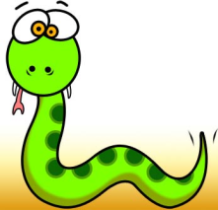
Retrieve
What kind of text is this?
• Who/Where/When/how/Why did…..?
• What happened when…..?
• How many…..?
• What happened to……?

