Winnington Park Primary School and Nursery

Science Policy

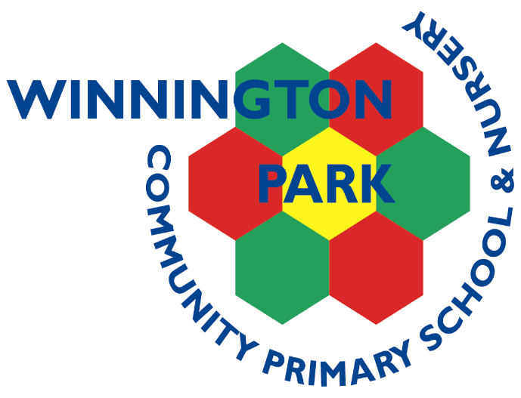

Completed by: Jennie Flackett

Updated: Autumn 2023

Review date: Autumn 2024
Winnington Park Community Primary School

Science Policy

Our School Vision:
Our vision is of a community whose members: children, parents, teachers and staff work collaboratively towards achieving an exciting and inclusive school, with high expectations and standards for all, within a happy, caring and secure environment.

Our Curriculum Vision
At Winnington Park Community Primary School and Nursery we aim to offer a creative and inclusive Curriculum which inspires, engages and challenges and in which children are partners in their own learning.

CURRICULUM INTENT
We ensure that children are given opportunities to widen their knowledge and understanding of the world and learn and apply skills which will make them successful learners for life as well as enhancing their spiritual, moral, social and cultural development. Children will become confident, independent and resilient learners who are willing to take risks. They will have high aspirations and be proud of their achievements. We aim to give everyone the opportunity to fulfil their highest potential, both academically and in respect of their wider interests and talents.
Our curriculum has clear end points and our lessons are sequenced so children’s learning builds towards these. The children’s new knowledge and skills builds on what they have been taught before and is designed for the children, families and community of Winnington Park.

IMPLEMENTATION
Our children learn through a knowledge based curriculum which develops children’s skills. We endeavour to engage our children and completely immerse them in their learning. Topics are progressive whilst being inclusive and challenging. They provide children with the knowledge and skills needed for the next stage in their learning and later life.
We celebrate and value all subjects and provide opportunities to apply key skills in all areas of learning. We have high expectations of achievement, progress, behaviour and presentation. Our children enjoy developing their learning through enhanced projects such as writing and reading weeks, art workshops, trips and residential.

IMPACT
The impact of our curriculum ensures children are prepared for the next stage of learning and later life.
Children who attend Winnington Park achieve well and are equipped with the knowledge and cultural capital they need to succeed in life.

Science Vision Statement:
Science at Winnington Park is exciting, interesting and informative. Children are encouraged to develop ideas and ways of working that enable them to make sense of the world in which they live, and to improve their knowledge and understanding through investigation and application of skills. They develop positive attitudes, confidence and competence and an ability to reason, predict and communicate scientifically.
Key Skills:
- Pattern seeking.
- Identifying, classifying and grouping.
- Observing over time.
- Researching using secondary sources.
- Conducting comparative and fair tests.

Strengths:
- Teaching staff are aware of the progression of skills, knowledge and scientific vocabulary for each topic.
- Pupils enjoy science and show competence and confidence in practical work.
- Substantive knowledge is embedded before disciplinary knowledge is taught.

Vulnerable Children:
Equality of opportunity at Winnington Park Primary School means that all children, taking account of gender, age, ability, disability, ethnic origin, faith, culture, social circumstances and sexual orientation have full access to all the curricular, pastoral and social opportunities offered by our science curriculum.
The Importance of Science:
Science in our school is about developing children’s ideas and ways of working that enable them to make sense of the world in which they live through investigation and using and applying process skills.

In teaching Science, we are developing in our children:
- a positive attitude towards Science and an awareness of its fascination;
- an understanding of Science through a process of enquiry and investigation;
- confidence and competence in scientific knowledge, concepts and skills;
- an ability to reason, predict, think logically and to work systematically and accurately;
- an ability to communicate scientifically;
- the initiative to work both independently and in co-operation with others;
- the ability and meaning to use and apply science across the curriculum and real life.

Aims:
Our Science Policy follows The National Curriculum 2014 for Science Guidelines for KS1 and KS2 and aims to ensure that all pupils:
- develop scientific knowledge and conceptual understanding through the specific disciplines of Biology, Chemistry and Physics;
- develop understanding of the nature, processes and methods of Science through different types of science enquiries that help them to answer scientific questions about the world around them;
- are equipped with the scientific knowledge required to understand the uses and implications of Science, today and for the future.

Foundation stage follows the statutory framework for the Early Years Foundation Stage.

Spiritual, Moral, Social and Cultural Aspects:
Science contributes to SMSC development through opportunities to reflect on the diverse nature of our world, thinking about changes in the environment and benefits of scientific developments and developing our awareness of the interdependence of all living things and materials of the earth. Pupils will become increasingly curious and develop an open mindedness to the suggestions of others through opportunities to explore how science has a major effect on the quality of our lives. Studies of Scientists and their contributions gives children the chance to reflect on social and cultural characteristics of society.

Planning:
School curriculum
The programmes of study for Science is set out year-by-year for Key Stages 1 and 2. Teachers will base their planning on the programmes of study for their relevant year groups. For science, the Foundation stage teachers will follow the 'Understanding the World' section in the Statutory framework for the Early Years Foundation Stage.

Scientific knowledge and conceptual understanding
The programmes of study describe a sequence of knowledge and concepts. While it is important that pupils make progress, it is also vitally important that they develop secure understanding of each key block of knowledge and concepts in order to progress to the next stage.
Pupils should be able to describe associated processes and key characteristics in common language, but they should also be familiar with, and use, technical terminology accurately and precisely. They should build up an extended specialist vocabulary. They should also apply their mathematical knowledge to their understanding of Science, including collecting, presenting and analysing data.

The nature, processes and methods of science
‘Working scientifically’ specifies the understanding of the nature, processes and methods of Science for each year group. It should always be taught through the programme of study and not be taught as a separate strand.

Attainment targets
By the end of each key stage, pupils are expected to know, apply and understand the matters, skills and processes specified in the relevant programme of study.

Foundation stage
The main focus of science teaching in EYFS is to enable pupils to understand the world by guiding children to make sense of their physical world and their community through opportunities to explore, observe and find out about people, places, technology and the environment.

Key Stage 1
The main focus of science teaching in Key Stage 1 is to enable pupils to experience and observe phenomena, looking more closely at the natural and humanly-constructed world around them. They should be encouraged to be curious and ask questions about what they notice. They should be helped to develop their understanding of scientific ideas by using different types of scientific enquiry to answer their own questions, including observing changes over a period of time, noticing patterns, grouping and classifying things, carrying out simple comparative tests and finding things out using secondary sources of information. They should begin to use simple scientific language to talk about what they have found out and communicate their ideas to a range of audiences in a variety of ways. Most of the learning about Science should be done through the use of first-hand practical experiences, but there should also be some use of appropriate secondary sources, such as books, photographs and videos.
Pupils should read and spell scientific vocabulary at a level consistent with their reading and spelling knowledge at Key Stage 1.

Lower Key Stage 2 – Years 3 and 4
The main focus of Science teaching in Lower Key Stage 2 is to enable pupils to broaden their scientific view of the world around them. They should do this through exploring, talking about, testing and developing ideas about everyday phenomena and the relationships between living things and familiar environments, and by beginning to develop their ideas about functions, relationships and interactions. They should ask their own questions about what they observe and make some decisions about which types of scientific enquiry are likely to be the best ways of answering them, including observing changes over time, noticing patterns, grouping and classifying things, carrying out simple fair tests and finding things out using secondary sources of information. They should draw simple conclusions and use some scientific language, first, to talk about and, later, to write about what they have found out.
Pupils should read and spell scientific vocabulary correctly and with confidence, using their growing reading and spelling knowledge.

Upper Key Stage 2 – Years 5-6
The main focus of Science teaching in Upper Key Stage 2 is to enable pupils to develop a deeper understanding of a wide range of scientific ideas. They should do this through exploring and talking about their ideas; asking their own questions about scientific phenomena; and analysing functions, relationships and interactions more systematically.
At Upper Key Stage 2, they should encounter more abstract ideas and begin to recognise how these ideas help them to understand and predict how the world operates. They should also begin to recognise that scientific ideas change and develop over time. They should select the most appropriate ways to answer Science questions using different types of scientific enquiry, including observing changes over different periods of time, noticing patterns, grouping and classifying things, carrying out fair tests and finding things out using a wide range of secondary sources of information. Pupils should draw conclusions based on their data and observations, use evidence to justify their ideas, and use their scientific knowledge and understanding to explain their findings.
Pupils should read, spell and pronounce scientific vocabulary correctly.

Assessment, Recording and Reporting:
Assessment opportunities in science for key skills depends on the type of activity or lesson and the age or ability of the child. The assessment methods can include:

- Observing children working, individually or in groups
- Questioning and listening to children
- Assessing written work (where appropriate, KS2 and KS1 have individual science books whereas EYFS have a class book)

At the end of each unit or on a termly basis, in accordance with other subject assessments, the teachers will record their assessments on the appropriate assessment grid. All the children’s science books will be kept and passed up to their next class at the end of each year so in Y6 the teacher will have access to Y3, 4 and 5 books to help make their teacher assessment.

Health and Safety:
Class teachers are responsible for the health and safety of the children in their class. Classroom activities should be as safe as possible and children should be taught to use the equipment properly. Teachers should refer to the school Health & Safety policy and the COSHH guidance 'Be safe' for direction, if necessary.

Resources:
Science resources are kept in the Science cupboards outside the Y2 classroom. There are a range of resources and equipment available to the children. It is the responsibility of the class teacher to ensure the equipment they require is available prior to their teaching.

Use of ICT:
Where appropriate, planning will incorporate the use of ICT through the use of software, digital cameras, sensing equipment, databases, internet and data loggers.

Differentiation:
Children bring many different levels of experience and understanding of science to the classroom. In the planning of the science curriculum there is ample scope to raise standards of achievement, enquiry and interest for whatever stage of development each child has reached. Differentiated activities should build on these differences and past achievements by presenting appropriate challenges alongside high, yet realistic expectations. Differentiation for pupils with special learning difficulties, as for all other pupils, should be planned to ensure that all individuals enjoy the fullest possible benefit of a broad and balanced curriculum.

Review:
This policy will be reviewed by the subject leader every year.

Mrs Flackett
November 2023

