

|  |  |  |  |  |  |
| --- | --- | --- | --- | --- | --- |
| ***ASPIRE*** | ***SAFE*** | ***TRUST*** | ***RESPECT*** | ***KIND*** | ***PRIDE*** |

25th March 2024

Dear Parents, Carers and Children,

**WINNINGTON PARK READING FESTIVAL**

Our Reading Festival is taking place from Friday 19th April to Wednesday 1st May. The Scholastic book fair will be on site with lots of great books and stationery to buy. As always, the monetary amount of books that we sell the more money we get back from Scholastic to buy more books for school!

This year sees the return of the popular parent-child Reading Cafes for Reception to Year 6. These are a lovely opportunity to come in to school and share some of the lovely books on offer whilst having a cup of tea or coffee and even a biscuit! The PTA will be running the café but we would appreciate it if you were able to send in donations of biscuits & cakes for the children to share.

Please see the table below for details on when your child’s café is along with details of when we will be opening the book fair after school.

|  |  |  |  |  |
| --- | --- | --- | --- | --- |
| **Day** | **Time** | | **Class** | **After school Fair**  **3:15-4:00pm** |
| **Fri 19th April** | **9.00am-9.40am** | | Year 6 Mrs Hall Miss. Evans |  |
| **2.30pm-3.10pm** | | Reception Mrs. Jurgis |  |
| **Mon 22nd** | **9.00am-9.40am** | | Reception Miss Ikin | Monday 22nd |
|  | |  |
| **Tues 23rd** | **9.00am-9.40am** | | Year 1 Mrs. Ford & Mrs, Tuohy |  |
| **2.30pm-3.10pm** | | Year 2 Mrs. Norris |  |
| **Weds 24th** | **9.00am-9.40am** | | Year 2 Mrs Gill & Mrs. Flower | Wednesday 24th |
| **2.30pm-3.10pm** | | Year 4 Mrs Conheeney |
| **Thurs 25th** | **9.00am-9.40am** | | Year 5 Mrs. Flackett |  |
| **2.30pm-3.10pm** | | Year 4 Mrs. Worsley |  |
| **Fri 26th** | **9.00am-9.40am** | | Year 3 Mrs. Mitchell |  |
|  | |  |  |
| **Mon 29th** | **9.00am-9.40am** | | Year 5 Mrs. Coot | Monday 29th |
|  | |  |
| **Tues 30th** |  |  | |  |
| **2.30-3.10pm** | Year 3 Miss Sayles (Mrs. Harriot) | |  |
| **Weds 1st May** |  |  | | Wednesday 1st |
| **2.30-3.10pm** | **Year 1 Miss Hope** | |

Classes will also be visiting the fair during the week with their class teachers to enjoy sharing stories with each other. There will also be an increased focus on reading for pleasure across the whole school.

**Competition Time!**

This week your child will be bringing home a paper plate to transform into a book character or a scene from a book. They could draw, paint or collage or whatever they wish. Here are some ideas of what other children have done. A winner will be chosen from each class and everyone’s artwork will be displayed for us all to enjoy. **The deadline for entries is FRIDAY 26th APRIL.**

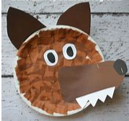 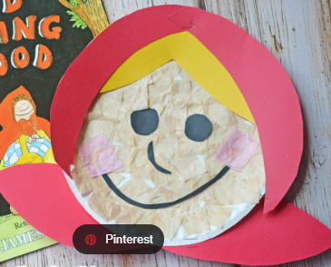 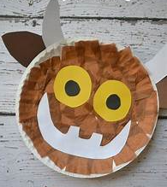

  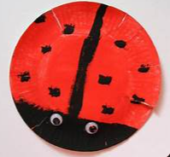

I hope that lots of you will be able to join us at one of the Reading Cafes or after school book fairs and that as many children as possible are able to find time over the Easter break to have a go at making a plate.

Mrs. J. Flower

Reading Lead

Winnington Park Primary School and Nursery, Firdale Road, Winnington, Northwich, Cheshire, CW8 4AZ

Tel: 01606 74371 email: admin@winningtonpark.cheshire.sch.uk website: www.winningtonpark.cheshire.sch.uk

Headteacher: Mr Rob Cole email: head@winningtonpark.cheshire.sch.uk



